Himalayans

Origin
Early in the history of showing cats breeders built on characteristics already present in the breeds they wanted to work with. By selectively breeding for desired qualities they improved the qualities they liked and at the same time eliminated what they considered to be undesirable characteristics. In the 1920’s people became interested in crossing Persian and Siamese cats “to see what would result from the cross”. Records of the experimental breedings were kept, and now the history of the development of the Himalayan breed is so well documented that there are probably people who can recite it in their sleep.

In the 1920's there was an experiment by geneticists hoping to produce a longhaired, colorpoint cat; Persians were bred with Siamese, hoping to produce pointed, longhaired, Persian type, kittens. However, the Persian(s) used in this project were white; at that time no one understood that white was not a color, but a masking factor. So it is unlikely that anyone working with that project understood that they were working with dominant white masking genes in the Persian, plus dominant shorthair and recessive color point in the Siamese. The chances of getting a longhaired, pointed kitten from this cross were slim to non-existent at best, and to make it a short story, (well, several years/generations really are not all that short a time) they didn't produce any longhaired, pointed kittens and eventually abandoned the project. (Nothing is mentioned about short-haired color point kittens being produced.)

In recent years some breeders have deliberately bred Himalayans with white Persians, knowing that half or all of the resulting kittens in the first generation would be white. If the white cat has only one masking gene, half the kittens can be expected to be white*. If the white cat has two white masking genes, in the first generation (of white to pointed parents) kittens will be white CPC’s (Color Point Carriers).

*This is theory – well proven - but cats are not interested in theory. Breeders frequently have no idea what color the kittens will be until they are born, and Mom-Cat (who didn’t read the books about the theory of color genetics in cats) doesn’t care about color; she will love them all.

In the second generation of breeding white CPC to white CPC there is a chance that one of the white kittens will be blue-eyed with deep blue eyes. That kitten could be a traditional blue-eyed white Persian or a white Persian masking color point. At this time test breeding to pointed Himalayans is the only way to determine if the blue-eyed white (CPC X CPC) Persian is masking the Himalayan pattern. If the cat is masking only the pointed pattern, breeding the cat to a Himalayan should produce only blue-eyed white or pointed kittens. Blue-eyed white cats masking only the Himalayan pointed pattern are sometimes referred to (by their owners) as white points, as this is the most easily understandable description. DNA testing for color point may soon allow breeders to determine if their blue-eyed white cat is - or is not - masking color point.

In the second generation (white CPC X white CPC) there will be white kittens which are masking another color as well as color point. When bred to pointed cats, those will produce a variety of colors, with a one in two chance of producing a pointed kitten. But cats don’t care about theory; they may produce litters in which all or none of the kittens are pointed.

When pointed cats are bred to pointed cats, all of the kittens will be pointed.

In the 1930's Doctor Clyde Keeler and Virginia Cobb decided to try to discover more about the inheritance of the colorpoint pattern in longhaired cats, with the objective of producing a longhair colorpoint. Their interest was apparently primarily in determining if this could be done and how the pointed pattern was inherited. Five years later their project produced a longhaired, pointed cat, NEWTON'S DEBUTANTE, and once they had succeeded the project was ended. Their documentation would be useful to others, who - years later - became involved in breeding programs to produce colorpoint longhair cats.

World War II forced everyone to concentrate on the necessity of fighting and winning the war. There was no time for thinking of much more than keeping cats and dogs fed, let alone think of producing more purebred mouths to feed. If there was canned food for cats and dogs, it would not have been of the quality that we now have. In the early 1950's the most popular canned cat food in the USA was Puss N Boots, and it was primarily fish. When the can was opened, it smelled strongly of fish, and after the cat had eaten, for a time the cat’s breath also smelled strongly of fish. (Kitty-kisses immediately after meals were not encouraged).Small fish bones (soft from being canned) were clearly visible among the contents of the can.

After World War II Mother Nature stole a march on cat breeders, producing longhaired, pointed cats, and caused a strong desire among cat breeders to "fiddle" with things and produce more pointed, longhaired, cats.

When Mr. B.A Sterling-Webb, Briarry cattery, of Richmond, England, discovered a seal point longhaired stray cat in a local churchyard late in the 40’s or very early in the ‘50’s, he took her home, named her Bubastis Georgina, and she was his first colourpoint longhair breeding cat. He soon became very interested in breeding to produce colour point Persians, and, with Mrs. J. P. Harding, of Mingchiu Cattery, he worked toward that goal for the remainder of his life. After the death of Mr. Sterling-Webb, the Harding’s continued breeding toward a color point longhair cat that met the Persian standard.

At the time Briarry and Mingchiu were starting to breed to produce colourpoint longhair cats, a breeder in the Netherlands, Regina van Wessem, Siyah Gush cattery, was working alone to produce colourpoint longhaired cats. Ms. Van Wessem became primarily interested in the chocolate and lilac points, and her cattery name was on many nice quality chocolate and lilac points imported into the USA in the early 1970’s. Ms. Van Wessem died in 1973, but her work was carried on by Mrs. Prose, Hoog Moersbergen cattery.
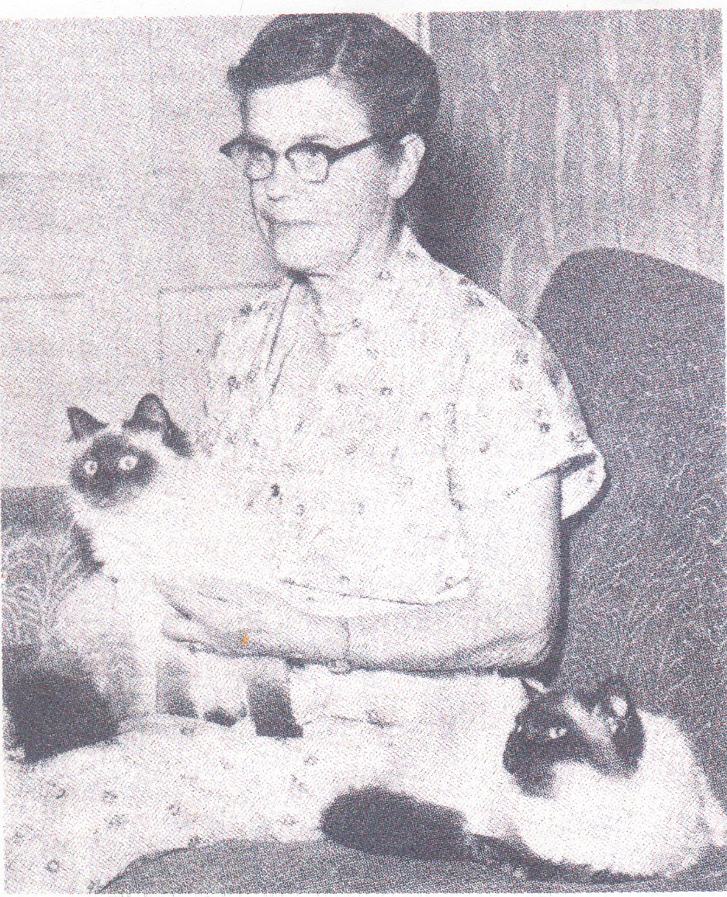
In 1955, in England, the GCCF (Governing Council of the Cat Fancy) accepted the Colourpoint Longhairs for competition; Briarry and Mingchiu Longhair Colourpoint cats were shown at GCCF shows, and did well.

Shortly after Mr. Sterling-Webb discovered Bubastis Georgiana, Marguerita Goforth, GoForth cattery in CA, was starting her program to produce a pointed Persian. A friend asked Mrs. Marguerita Goforth to care for her cats while she was moving, one cat being a longhaired color point female. Mrs. Goforth was intrigued by this cat, and asked to be allowed to use her for breeding.

In 1957 Mrs. Goforth went before the CFA board and asked to have the colorpoint longhair cats designated as the HIMALAYAN breed, as this name was the designation for other varieties of animals exhibiting the color point pattern, i.e. rabbits, goats, etc. Mrs. Goforth’s request was approved
Mrs. Goforth holding GoForth Grand Design with Princess Himalayan Hope at her side.

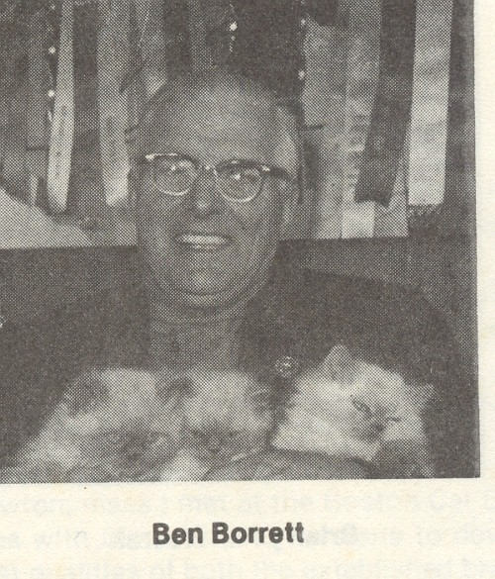
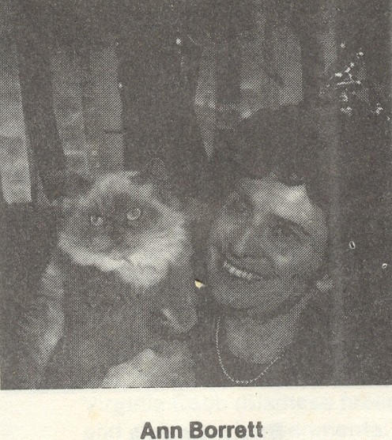
Ben and Ann Borrett, Chestermere cattery in Canada, imported cats from Briarry and Mingchiu catteries, as well as introducing cats from Chatelaine Cattery and several other breeders. They quickly became well known as breeders of fine Himalayans. It was the Borrett’s who drew up a Standard of Perfection specifically for the developing Himalayan breed. It was the Borrett’s new standard that was used by Mrs. Goforth when she asked the CFA board to accept HIMALAYAN as the name for this new breed.

While other breeders were crossing their Himalayans with stud-book Persians to improve type, the Borrett’s were using only Himalayans in their breeding program. Although they must have produced many kittens that did not meet the standard, they did produce many fine Himalayans whose names are still recognized at this date.

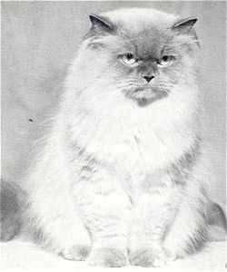
While other breeders were crossing their Himalayans with stud-book Persians to improve type, the Borretts were using only Himalayans in their breeding program. Although they must have produced many kittens that did not meet the standard, they did produce many fine Himalayans whose names are still recognized at this date.
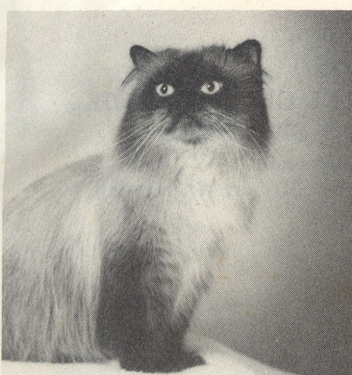
Chestermere Kinuba of Nevah-Tep (far lrft left) in 1964 was the first Himalayan granded in CFA. He also granded in three other associations.

Chestermere Chu-Woo of Katzpaugh was a GC and the sire of many excellent show quality Himalayans

Breeding stud book Persians with Himalayans produced all solid color cats, many of exceptional quality, but those cats had no value other than as a step in the breeding program; they could not be shown in any North American association. When Persian CPC’s were first shown it was as solid color Himalayans, but only in colors which were accepted for competition in the Persian class. This left the breeders of Chocolate and lilac point Himalayans with self-chocolate and self-lilac cats in limbo, as solid chocolate and solid lilac cats were not within the colors accepted for competition in the CFA Persian class.

To allow the self-chocolate and self-lilac to be shown, it was decided in some associations late in the 70’s to re-register their cats as a separate breed, to be known as the Kashmir breed. Some were shown, but their success in the show ring was limited, and they slowly disappeared from competition.

When TICA was chartered many welcome changes were soon introduced to the TICA members. One was that solid color cats (CPC’s) from Persian to Himalayan breedings, would compete equally in the Persian class. Another decision – this one by the Himalayan breed section – was that any color or pattern of Himalayan which resulted from breeding with registered Persians would be accepted for competition in the Himalayan class.

So, while other associations were fighting over accepting new colors, color combinations, or patterns for Championship competition, those new colors, color combinations, and patterns were already competing in TICA.

Important dates
1955 GCCF (in England) recognized the Himalayan as a Colourpoint Longhair, a division of the Persian breed.
1957 The Borretts showed two imported Himalayans at a Canadian show. Mrs. Goforth showed her Himalayans at a west coast show. The Borretts drew up a standard for the new breed, and Mrs. Goforth asked CFA to accept the name of this new breed as Himalayan. The other North American registries also accepted the name of this new breed as Himalayan. CFA recognized Himalayans for competition. Accepted colors were seal pt, blue pt, chocolate pt and lilac point.
1966 Chestermere Kinuba of Nevah-Tep, a blue point Himalayan, became the first GC Himalayan in CFA. Kinuba went on to grand in three other assns.
1973 GC Lord Byron became the first Himalayan national winner in CFA.
1984 CFA accepted the Himalayan breed as the color point division of the Persian breed, allowing all CPC’s to compete in the Persian class.
1989 Ch. Westpoint Brigadier of Thesaurus, a blue point Himalayan, became the first Himalayan DM.

Disposition/Personality
Himalayans are thought by breeders of short hair breeds to be lazy, slow, and not much more than furry lap-warmers. This is far from the truth – except for the furry, lap-warming, part. They are also warm and cuddly bed-buddies when they finally settle down to go to sleep.

Himalayans are friendly and outgoing, making good family pets. Kittens will chase toys for a considerable time, and when tired they may all fall asleep in a pile.

Himalayans seem to get along well with cat-friendly dogs, but of course they have to be the “top cat” at all times. One must remember that CATS RULE!

Standard
At the time the Briarry and Mingchiu Longhair Colourpoint cats were first bred and shown (in England) the standard for the new variety was the same as the other Longhair cats in GCCF. The Longhair varieties of cat are characterized by a massive “cobby” body, a compact and powerfully built frame. With short legs, wide feet and short tail. The head is round, with good cranial width, the ears small, tufted and outwardly directed, the nose short and well turned off the forehead, and the face wide with large round eyes. The coat is long, the hair silky for choice, rather than wooly, and in winter a long frill frames the face, the tail carrying a full brush the width of the body.

When TICA was formed it was with the consideration that the goals would be toward the phenotype of each breed rather than the genotype, so CPC’s were to be shown in the Persian class and pointed Persians would be registered and shown as Himalayans. Both Persians and Himalayans could be from the same litter. In addition, soon after the formation of TICA, the Himalayan breed section approved allowing any (color or pattern) pointed cat, resulting from breeding with (registered) Persians, to be accepted for showing as a Himalayan. This meant that breeders could breed for bi-color point and shaded point Himalayans, or any combination of colors and patterns, and the resulting pointed cat would be automatically accepted for championship competition.

In CFA this was not true; breeders have had to battle for each color pattern they want to see included in Championship competition. Lynx points are now accepted in all colors, but bi-color point, shaded/smoke points are not yet accepted for competition in the pointed Persian division.

When TICA was a first organized, each breed had its own standard, written for each breed by the breed committee and approved by the breed section. Although Persians, Himalayans, and Exotic Shorthair were basically the same, each was judged by a separate standard.

There came a time when it was decided that the basic differences between the Persian, the Himalayan, and the Exotic Shorthair breeds were primarily visual. Persians were any color other than pointed, Himalayans were Persians with color points, and Exotic Shorthair was either/all of the above, but with a plush, dense, short, coat. It was at this time that it was decided that the three breeds would comprise a genetic group, and would be judged by the same standard other than their differences of coat color, pattern and length. The long haired kittens that sometimes result from breeding Exotic Shorthair to Persian are shown in the Persian (or Himalayan) class, depending on which color/length/pattern section of the standard they meet.

Persian breeders refer to their cats as Persians; Himalayans are usually referred to as Himmies, and Exotic Shorthair breeders frequently refer to their cats as “Zots”. However, Persian and Himalayan breeders may sometimes be overheard referring to the Exotic Shorthairs as “Wash and wear Persians”.

The Himalayan section of the standard calls for a cat that is “identical to the Persian but distinguished by the points on the cat’s extremities (the facial mask, feet, ears, and tail) which results in a Persian-type cat with the coloring and deep blue eyes of the Siamese-patterned cat”. The Persian section of the standard calls for “a long coat, flowing all over the body with a dense undercoat giving the coat full volume. The ruff should be immense”.

Over all, the standard for all three breeds calls for a cat that is “a strong cat with excellent boning and musculature; a well-balanced cat, giving the impression of robust power. The face should be round with a sweet, pleasant expression and large, round, expressive eyes. The cat should be well-balanced physically and temperamentally, gentle and amenable to handling”.

Allowances for females are called for, considering that females will generally be smaller than males, but they should be in proportion and balance for the size of the usually smaller females.

Sources
Colourpoint Longhair & Himalayan Cats, author S. M. Manton, F.R.S.
The Himalayan, Cat of the 80's author Linda Stacy. Contributing authors: Patrick Horan, Barbara Naviaux, Cindi Bossart V.M.D. and Pat Horan with Judy Brocato
Report on the Himalayan by Debbie Lopeman
Persian Breed Group Standard 05-01-2004
http://www.himalayancatsonline.com/a_himihistory.shtml PandeCats web page.
http://www.showcatsonline.com/x/boris_teron.shtml

Colourpoint Longhair & Himalayan Cats by S.M.Manton FRS p.15
TICA Persian breed group standard

